UDS_TST_0130

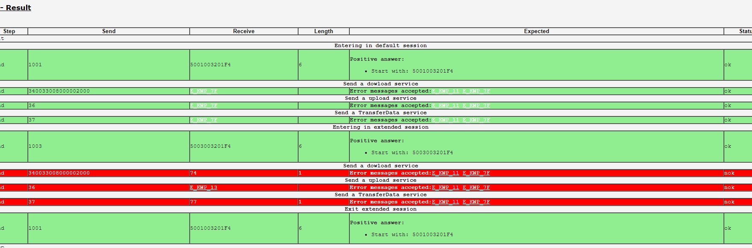

From the test result we could find that in default(1001) they are getting expected result

But in 1003 ie extended session they are not getting expected result

The services 34 36 37(request download , transfer data, request transfer exit ) are available to both programming and extended session but they need them only in